Edinburgh College

Sanel Contreras EC2133160

H17R35 - Mobile Technology

Assessment 02 – Report (LO2-LO3)

Date: 26/05/2023

Contents

1. Problem Description 3

2. Requirements Specification 4

Functional Requirements: 4

Non-Functional Requirements: 4

Constraints: 4

3. Navigation Map 5

4. Wireframes 7

5. Storyboards 9

6. Design Justification 10

7. Prototype 12

References 15

# Problem Description

The senior college management has requested the development team to explore the feasibility and practicality of creating a mobile app that will serve as an extension to the current information portal. The app is intended to expand the reach of the portal and provide students and staff with a convenient means of accessing sustainability information. Both the users and the clients - students, staff, and senior college management - have expressed an interest in the development of this app. In terms of where and when, the app should be available on mobile platforms such as Android and iOS, and it should be accessible to users both on and off-campus. It is important to note that developing a mobile app is a complex process that requires careful planning and execution. The development team, consisting of seven members of staff, will need to allocate adequate time and resources to ensure the app is reliable, user-friendly, and meets the clients' requirements.

Moving on to the Why and How, the development of the mobile app will enable the college to collect valuable data on users' travel and transport choices. The app will allow users to opt-in to sharing their GPS locations, which can be used to monitor and estimate their travel distances and transport choices. This information will provide the college with insights into users' behaviour, allowing them to make informed decisions on how to improve sustainability efforts. In terms of How, the development team, led by the manager and chief technical architect, will need to carefully plan and execute the project, taking into account technical aspects such as programming languages, user interface design, and database management. By creating a user-friendly app that engages with users through features such as a chat/bulletin board, the college can foster a culture of sustainability and make a meaningful impact on the environment. Ultimately, the development of this mobile app will serve as a step towards promoting sustainability and creating a more eco-friendly college community.

# Requirements Specification

## Functional Requirements:

The app will have an opt-in GPS tracking feature that allows users to share their location data with the college for monitoring and analysis.

The app will provide users with information on sustainable transportation options based on their location and travel history.

## Non-Functional Requirements:

The app will be available for download on the college website for both Android and iOS platforms. This ensures accessibility across different device types.

The app will feature a chat/bulletin board that allows users to engage in discussions and provide feedback. This enhances user engagement and interaction.

## Constraints:

The app will offer rewards to users who engage in sustainable behaviours, such as using eco-friendly transportation options. This introduces an incentive mechanism, but the reward system needs to be designed and maintained properly to ensure fairness and motivation.

The app will allow users to exchange their earned rewards points with other users, creating a sense of community and encouraging sustainable practices. However, this should comply with privacy and security policies to ensure safe exchange and prevention of misuse.

# C:\Users\ec2133160\Downloads\MicrosoftTeams-image.pngNavigation Map

This navigation map describes a layout of the app that promotes sustainable transportation and community sharing.

**Home Page:** This is the initial page a user encounters. It provides an overview of what the app does and its main features.

**Sign-up:** A section accessed from the Home Page where new users can create an account. This involves gathering necessary information such as name, email, password, etc.

**Log in:** A section also accessed from the Home Page. This is for returning users who already have an account to access their profiles and use the app's features.

**After logging in, users have three main paths:**

**Record and Track Activity:** This section allows users to record their activities related to sustainable transportation (like biking, walking, using public transport). This could involve recording distances, times, routes, etc., and perhaps storing and displaying this data over time.

**Create an Offer:** This is a feature that allows users to advertise something they can offer to the community, like carpooling, bicycle rental, etc. It would involve creating a profile for the offer, describing what is being offered, terms of the offer, and perhaps uploading photos.

**Visit Marketplace:** This is a section where users can browse offers created by other members. This could display offers in a list or grid, sorted by categories, distance, rating, etc. It provides a way to view more details about an offer and a way to contact the member offering it.

This structure encourages user interaction and a sense of community, while promoting sustainable transportation and sharing economy principles.

# Wireframes

The next wireframes are showing the landing page, sustainability tab and collection points tab.

Landing page will allow users to sing in with their account or also give the option to create a new account.

Sustainability tab give access to sustainability options available, to record healthy habits such as walking to university and also give the option to exchange points.

The collection points tab give access to use the points as well as to see statistics on how points have been earned and spent.

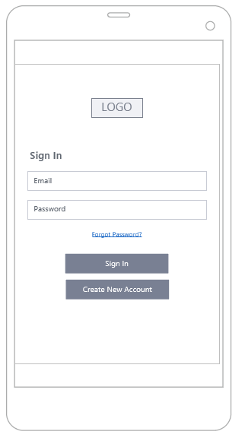

Figure 1 Home page

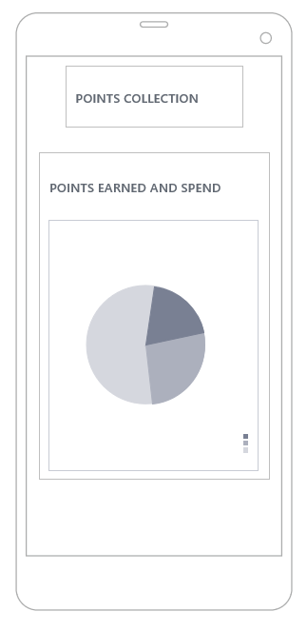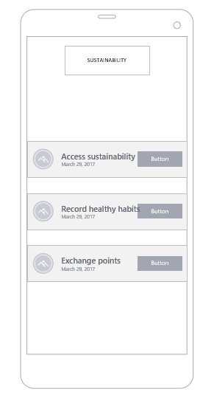

Figure 3 collection points

Figure 3 Sustainability tab

# Storyboards

# Design Justification

In designing this application, I have firmly adhered to key design principles to ensure it's highly functional, user-friendly, and visually appealing.

I incorporated predictive text to enhance user experience by streamlining typing on the mobile interface. This feature not only saves time but also significantly reduces input errors, making navigation within the app more efficient.

To ensure uniform and error-free data entry, I utilised data pickers for date of birth inputs. This tool negates potential confusion around different date formats, thereby offering an intuitive and internationally applicable data input approach.

My choice of a green palette for the colour scheme symbolises the theme of sustainable transport. Besides being visually attractive, the green palette signifies nature, sustainability, and tranquillity, aligning with the app's commitment to eco-friendly practices and resonating with users' sustainability values.

I paid particular attention to the background colour in terms of accessibility and readability requirements. A light background paired with dark text has been chosen, given its proven effectiveness for readability on mobile devices. This high contrast ensures clear visibility and legibility, thereby enhancing the overall user experience.

In line with the principles of inclusive design, my primary goal was to make the app accessible to as many users as possible, including those with visual impairments. Accordingly, I designed the text and background contrast to meet the Web Content Accessibility Guidelines (WCAG) 2.1, thus promoting readability for all users.

To sum up, every design aspect of this app has been guided by principles that ensure a user-centric, inclusive, and aesthetically consistent experience, further bolstering my commitment to promoting sustainable transport.

The design of my app can be significantly improved by focusing on two primary areas: Optimising the user flow and minimising clutter.

Optimising the user flow entails understanding how users interact with the app and identifying the common friction points during task completion. One method to improve user flow is through "chunking" for big tasks. For instance, if a task requires numerous steps and user actions, I can break it down into smaller subtasks. This method can be seen in progressive checkout flows in e-commerce apps, where the checkout process is divided into several steps, each requiring a user action. Limiting the number of actions required by the user will also improve comprehension. Lastly, I can use the information already known about the users to provide a natural next step and guide them through the process.

Minimising clutter involves delivering relevant information and avoiding irrelevant information. By overloading the interface with too much information such as extra buttons, images, or icons, users can become overwhelmed. This is particularly crucial in mobile apps where screen space is limited. To combat this, I'll focus on showing only what is necessary on the current step of the user flow. For example, when a user is making a choice, I'll reveal enough information to allow them the choice, then delve into the details on the subsequent screens. By cutting out the clutter and optimising user flow, I can enhance the overall user experience and functionality of my app.

# Prototype

Figure 01: launching and log-in.

Figure 02: Registration

Figure 03: Sustainable transport

Figure 04: Good transport choices

Figure 05: Marketplace

# References

John Piperias; url, Design Justification - lecture 09.ppt [Last Accessed 23 May 2017].

"UXPin Team"; https://www.uxpin.com/studio/blog/mobile-app-design-best-practices/, "Mobile App Design: The Basic Points for High Performance" [Last Accessed 26 May 2023].